KIRKLEES COUNCIL
STOCKS LANE, BATLEY

NOTICE IS HEREBY GIVEN that following identified safety issues at the zebra crossing running between the Batley C of E J&I School and Batley All Saints Church Kirklees Council propose widening the existing zebra crossing by an additional 4 metres north-eastwards, and extend the zig zag markings accordingly under section 23 of the Road Traffic Regulation Act 1984, as amended.

This will increase pedestrian / driver inter-visibility at times when north-east bound traffic is queuing on Stocks Lane through the crossing area.

A copy of the plan showing the locations (and precise dimensions) of the proposed alterations may be inspected during normal office hours at:-

1. Reception, Streetscene Service, Flint Street, Fartown, Huddersfield;
- Customer Service Centre, Civic Centre 3, Huddersfield
- Batley Library, 14 Market Place, Batley, WF17 5DA
- or web address: http://www.kirklees.gov.uk/trafficregulation.

If you wish to object to the proposals you should send the grounds for your objection in writing to reach the undersigned by not later than 22nd December 2017 quoting reference DEV/JE/D126-170.

Dated 1st December 2017

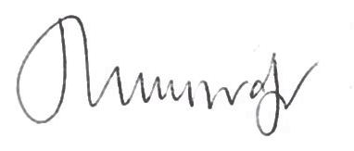

Julie Muscroft
Service Director – Legal Governance and Commissioning

Kirklees Council
Legal Governance and Monitoring
Second Floor
High Street Buildings
High Street
Huddersfield HD1 2ND

