KIRKLEES COUNCIL
(TRAFFIC REGULATION) (NO.17) ORDER 2016
BRADFORD ROAD CARLINGHOW HILL TRANSVAAL TERRACE
CHINEWOOD AVENUE BATLEY

The Council of the Borough of Kirklees made the above Order under their powers in the Road Traffic Regulation Act 1984 the effect of which, as it affects a length of road in the Batley area of the Kirklees district, will be to:
- Introduce on Bradford Road No Waiting at any time and No Loading Mon-Fri between 8am-9.30am and 2pm to 4.30pm
- Introduce on Carlinghow Hill No Waiting at any time and No Loading Mon-Fri between 8am-9.30am and 2pm to 4.30pm to remove school
- Introduce on Transvaal Terrace No Waiting at any time and No Loading Mon-Fri between 8am-9.30am and 2pm to 4.30pm
- Introduce on Chinewood Avenue No Waiting at any time and No Loading Mon-Fri between 8am-9.30am and 2pm to 4.30pm

The Order will take effect on 27th April 2018

A copy of the Order, together with a plan showing the affected lengths of roads and a statement of reasons for making the Order, may be examined during normal office hours at:-

1) Customer Service Centre, Civic Centre 3, Huddersfield
2) Web address: http://www.kirklees.gov.uk/trafficregulation

If any person wishes to question the validity of the Order, or any of its provisions, on the grounds that it, or they, are not within the powers conferred by the Road Traffic Regulation Act 1984, as amended, or that any requirement of the Act, or of any instrument made under the Act, has not been complied with, that person may within 6 weeks from the date on which the Order was made (i.e. by 11th June 2018) apply for the purpose to the High Court.

Dated this 27th day of April 2018
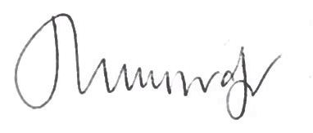
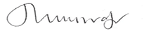
Assistant Director – Legal, Governance and Commissioning

Kirklees Council
Legal Services
2nd Floor
High Street Buildings
High Street
Huddersfield
HD1 2ND

