KIRKLEES COUNCIL
(TRAFFIC REGULATION) (No.10) ORDER 2017

A616 WOODHEAD ROAD BERRY BROW HUDDERSFIELD
MANDATORY CYCLE LANES

The Council of the Borough of Kirklees has made the above Order under their powers in the Road Traffic Regulation Act 1984. The effect of the Order is to reduce the length of the existing northbound mandatory cycle lane on A616 Woodhead Road at Berry Brow, Huddersfield by 32 metres from the existing end point, to a point 12 metres north of the existing traffic island where the speed limit changes from 40mph to 30mph; to reduce the width of the existing traffic island where the cycle lane currently terminates; to remove the ‘shared use’ status from the existing footway between the end of the cycle lane and the junction with Holme Park Close; and to provide new 30mph speed limit terminal signs displaying a road safety message in line with the Traffic Signs Regulations and General Directions 2016.

The order will take effect on 25th June 2018

A copy of the Order, together with a plan showing the affected length of road and a statement of reasons for making the Order, may be examined during normal office hours at:-

1) Customer Service Centre, Civic Centre 3, Huddersfield
2) on the Council’s weblink: http://www.kirklees.gov.uk/trafficregulation

If any person wishes to question the validity of the Order, or any of its provisions, on the grounds that it, or they, are not within the powers conferred by the Road Traffic Regulation Act 1984, as amended, or that any requirement of the Act, or of any instrument made under the Act, has not been complied with, that person may within 6 weeks from the date on which the Order was made (i.e. by 6th August 2018) apply for the purpose to the High Court, quoting reference DEV/DW/D116-1710.

Dated this 25th day of June 2018

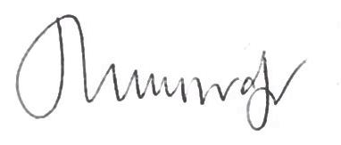
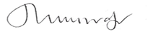
Assistant Director – Legal, Governance and Monitoring

Kirklees Council
Legal Services
2nd Floor
High Street Buildings
High Street
Huddersfield
HD1 2ND

