

**OUTDOOR EVENTS**

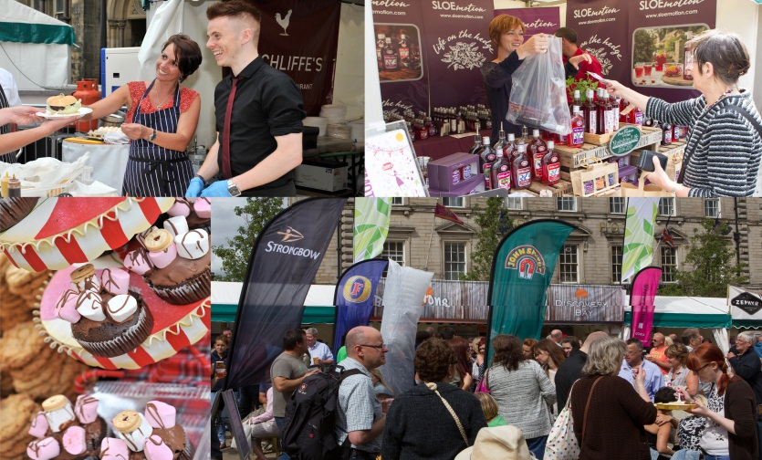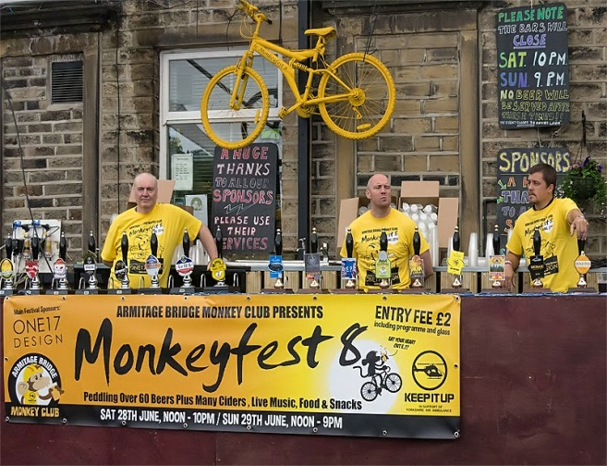

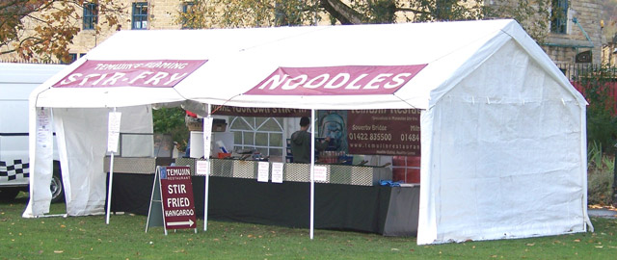

# A Guidance To Assist A Safe Outdoor Food Event

This guide has been produced to assist organisers and food business operators of food events. Each event is very different and will require different levels of management, services and provisions, however, there are elements that are common to all events and we advise you to use the information contained in this guide as a basis for planning your food event.

Catering at outdoor events is a high risk activity whether an established venue, market or a temporary/ mobile function. The large number of people, high risk products for sale, temporary structures place pressure on food safety management. This increases the risks associated with food handling and cross contamination.

Kirklees Environmental Health, Event Managers and the Food Business Operators must work together to secure and maintain high standards and conditions in respect of structure, equipment, cleanliness, licensing, food safety management, food standards and public safety.

**Food Business –Pre event**

All food business operators must register with the local authority where their business is based or where the vehicle used in connection with the food business is kept in accordance with Article 6 paragraph 2 EC Regulation 852/2004. Food businesses also need to ensure that they have appropriate public liability and employer liability insurance.

At the inspection the food safety officer will check how well the business is meeting the law on food hygiene. Three areas are assessed, these are:

* How hygienically the food is handled- how it is prepared, cooked, reheated, cooled and stored.
* The condition of the structure of the buildings- the cleanliness, layout, lighting, ventilation and other facilities.
* How the business manages and records what it does to make sure food is safe.

Each business is given a score for each of these areas. At the end of the inspection, the business is given a hygiene rating based on these scored areas. The rating shows how closely the business is meeting the requirements of food hygiene law and range from 0 to 5. The top rating of ‘5’ means that the business was found to have ‘very good’ hygiene standards whereas a rating of ‘0’ means urgent improvement necessary.

As an event organiser we strongly recommend that all food businesses attending your event have a hygiene rating of 3 or above. These ratings mean that the food business complies with food legislation. However, ratings of 2 and below mean that the food business does not comply with food legislation.

By only allowing food businesses with ratings of 3, 4 and 5 to trade at your event, you can therefore have confidence that the food they sell/serve is safe to eat. We suggest you make this rating your criteria in your event application process and include it in your event literature.

All food hygiene ratings are published on the Food Standards Agency website at [www.food.gov.uk/ratings](http://www.food.gov.uk/ratings)

# Food Safety Training

Event catering is a high risk activity and all food handlers are to be supervised and instructed and/or trained in food safety matters appropriate for their work activity.

Training is an area that is best dealt with during the pre-planning stages of the event. We recommend that you as the organisers may ask the food business operator for a copy of any certificates of training completed.

**For your information - please see attached list of approved training course providers in Kirklees.**

**TEMPORARY STRUCTURE**

This section is a guide for structure, walls, floors, lighting, ventilation, water/supply, and sinks.

**Structure**

The structure must be covered to tops and sides especially food preparation, equipment and storage areas. It needs to be of good strong construction which is weatherproof, windproof and designed to prevent the ingress of pests.

All the cooking equipment must be within the stall and must have adequate space available for the type of foods that are being prepared and cooked. Adequate food storage must be separate from the cooking and preparation areas, this may be difficult due to restricted space and this is when time separation must be followed. This is also when the design and layout must have maximum effect to ensure the risk of cross contamination is low and E-coli guidance is followed (For your information – please see attached E-coli guidance).

**Walls**

The finish and structure of the walls will depend on the length of time the stand will be in use and whether it will be used again. It must be readily cleansable, clean and free of mould or any loose particles which may cause physical contamination.

**Floors**

For flooring, the slip resistance is more important than the ease of cleaning; the food business operator must be prepared for wet weather when a floor covering should also be provided for serving areas. Dry clean cardboard may be acceptable. The food business operator must be able to demonstrate effective measures to keep mud out of the food preparation, storage, service and washing up areas- an example would be a change of footwear policy can help reduce contamination.

**Lighting and Ventilation**

It is necessary to install artificial lighting into a temporary structure. The lighting moisture ingress protected e.g. light diffuser covers or suitable outdoor lighting. All installation must be undertaken and checked by a suitably qualified and competent electrician.

It is often necessary to provide means of ventilation to a temporary structure as working temperatures can become unacceptable. It is best to provide a structure with ventilation flaps at high level. Food business operators should always considers this, but it is also dependant on the size of the structure, amount of heat being produced and length of time in use. Extraction fans may be used but should again be sited at high level.

**Water Supply**

There must always be an adequate supply of potable water available for hand, equipment and food washing. Wherever possible, mains water should be piped to the temporary stands. Where temporary pipes are being used, they must be clean and if possible sterilised before use and at regular intervals as part of the cleaning process. They must also be installed by a competent person. The Event organiser must be able to demonstrate that the temporary supply of water is potable during the event. The food business operator is also responsible that their water is potable and that their operation does not contaminate the water supply throughout the event.

If no mains supply of water is available then water will have to be supplied through small water tanks or larger tankers on the site. The large tanks must be filled from a mains supply and emptied each day.

If using water containers they must be clean, both inside and out, we recommend a chlorine based sterilant should be used to clean containers and all pipe work.

Ice must only be made from fresh or bottled water, and must be stored and handled in conditions which protect it from any contamination. We strongly recommend that the purchase of pre made ice is the best option.

If water butts are being used to keep drinks cold, these should also be kept free from any contamination, again a preferred option would be for the stall holders to hand out the drinks.

**Toilets**

An adequate number of flushable staff toilet accommodations needs to be provided that is within reasonable distance and must be connected to a suitable drainage system or provisions made for disposal of chemical toilets.

If it’s a larger event separate toilets should be provided for the food traders, they should not be expected to share the on-site toilets provided for the general public.

**Waste Water**

All waste water should be discharged into a proper drainage system where available .The site operator must also be able to demonstrate the arrangements in place for the disposal of waste water, if using waste water storage containers. A contingency plan for extreme wet weather conditions needs to be in place, if access to the containers is hampered by flooding or heavy mud restricts movement.

**Sinks**

The number of sinks that should be provided will depend on the operation; the following will need to be considered:

* How much food preparation is taking place
* The amount of equipment in use and how often it’s going to be cleaned
* The type of food being produced – ready to eat or preparation required.

All stalls must have suitable facilities for washing utensils, equipment and food. Washing up bowls or plastic crates are not suitable for kitchen catering for several days. Ideally a double sink unit for washing and rinsing should be used with a constant supply of hot and cold water. A large hot water boiler should be provided specifically for this purpose. All sinks must drain hygienically to a waste water container such as a sink waste pipe into a waste water carrier. The sinks must also be sufficient size to accommodate the food equipment in use.

Washing up at standpipes must not be permitted due to the risk of cross-contamination.

**BBQ’s**

All BBQ’s and any spit roasts must be sited to the rear or side of the structure and it must be on stable ground. Weather protection must be available for foods awaiting cooking/service.

**Food Preparation**

Through-out all operations, personal hygiene is the most important part of the operation to prevent cross-contamination.

One of the main problems facing any outside catering is having suitable storage facilities that will adequately protect food and maintain safe temperatures. The following are the key principles for safe storage of food:

* Keep raw and cooked food separated
* Protection from cross-contamination
* Keep food in suitable lidded containers
* Keep food stored off the floor
* Protection from extreme weather condition – heat, water and mud.

All work surfaces for food preparation must be constructed of cleanable, sturdy materials strong enough to accommodate all utensils pots and pans filled with food. Work surfaces, cooking facilities and storage facilities must be clean, smooth, impervious and capable of being cleaned and disinfected.

Vehicles, trailers etc used to transport food must be kept clean and in good repair. Where any food is being carried in the open air between vehicles or stands, arrangements must be in place to protect it from risk of contamination.

**Attached E-coli guidance for further details.**

**Cooking and Temperature control**

All catering areas must have sufficient refrigerated storage space for high risk food which includes effective temperature control.

High risk food must be transported, stored and displayed at a temperature of 8oC or below (ideally 1-5oC)

Food can be displayed unrefrigerated for up to 4 hours but this must be a one off and there must be a system in place for monitoring food past the 4 hours. For example after 4 hours food must either be discarded or placed under temperature control for example placed back into a refrigerator and sold from the refrigerator.

Hot food on display must be kept above 63oC if it is to be hot held for more than 2 hours. A probe thermometer will help food business operators monitor this. If food is displayed less than 63oC then it can be for no more than 2 hours. Again this is the responsibility of the food business operator to ensure these time and temperatures are being followed.

When cool boxes are being used in place of refrigerators it is the food business operator’s responsibility to demonstrate the effectiveness of such storage and time in the storage.

**Hand Washing Facilities**

If the business is only selling low risk open foods such as biscuits, sweets, olives etc and utensils are used for handling the food or when food is wrapped it is hard to justify the provision of a wash hand basin. But they will need to have antiseptic wipes/disposable gloves, but a food business where high risk food are handled alcohol based hand gels/sanitizer must only be used as a supplement to a fully equipped wash hand basin. The food business operator should not be allowed to operate unless they can demonstrate wash hand facilities are available.

Hand wash facilities must be:

* A basin or sink with a supply of hot and cold water
* Ideally be a purpose built unit connected to a water supply and drainage facility
* The supply of hand washing water must be separate from that used for making beverages for sale
* Soap and drying facilities must be available at all times

Thermos flasks of hot water are NOT acceptable as they do not hold enough water!

Larger stalls with several preparation areas and busy serveries will require multiple hand basins.

**Allergens**

There are big changes regarding the information a food business must be able to give to their customers. From 13th December 2014, the EU Food Information for Consumers Regulation (EU FIC) came into force.

You can find out more about the Regulations here:

<http://www.food.gov.uk/business-industry/allergy-guide/allergen-resources>

The EU law has listed 14 allergens that need to be identified if they are used as an ingredient in a dish. This means that all food businesses will need to provide information about the allergenic ingredients used in food sold or prepared by them.

# Events Organisers checklist

Please find below a checklist which can be used to help you identify that the food stalls are complying with Food Safety legislation.

|  |  |  |
| --- | --- | --- |
|  | Yes | No |
| Does the food business have a FHR of 3 or above? If a new business, are they registered with a LA? |  |  |
| Does the food business have food hygiene training certificates available? |  |  |
| Is the structure fit for purpose? E.g. Floors and walls suitable? |  |  |
| Do they have suitable and sufficient lighting? |  |  |
| Does the stall require ventilation? If so is it adequate for the needs of the business? |  |  |
| Is there a potable water supply available at all times? |  |  |
| Is there an adequate number of flushable toilets on site? |  |  |
| Is there a waste water drainage system available for all the food business? |  |  |
| Do all the food stalls have an adequate number of sinks for washing of equipment and utensils? |  |  |
| Do any stalls have BBQ’s? If so are suitably sited to the rear or side of the structure? |  |  |
| Do all the food stalls have a separate hand wash sink available with hot and cold running water, hand soap and drying facilities? |  |  |
| Are waste bins available for the food business and customers? Are they being emptied regularly? |  |  |

# bLANK PAGE INTENTIONALLY

# Food Business operators checklist

The checklist is based around Management responsibilities, and the 4 C’s:

1. **Cross Contamination**
2. **Cleaning**
3. **Chilling**
4. **Cooking**

The checklists will help you identify any hazards in your business and put the necessary controls in place to make sure the food is safe to eat. Most of these are common sense practices, which you have probably been following for years. If you answer “no” to any of the questions, then there is a potential problem which will increase risk of something going wrong. Please keep your completed checklist for when we next inspect your premises.

Once you have worked through the information, we recommend you use this pack to train your staff. You should also supervise them to check they are following all the procedures properly.

**Top tips:**

* Be prepared, have all the basics for hand washing and cleaning available at all times.
* Keep your menus simple. Work through your menu and estimate how much of each ingredient you will need for the event.

**For more information contact Leanne Perry, telephone 01484 2261000**

# Management

Managing your business effectively is vital for food safety. This section includes information on different management issues including, checks, suppliers, stock control and training/supervision of staff.

|  |
| --- |
| **Opening checks and setting up your stall**  ***You should do these checks at the beginning of the day*** |
| Your fridges, chilled display equipment and freezers are working properly |
| Your other equipment is working properly |
| Staff are fit for work and wearing clean work clothes |
| Food preparation areas are clean and disinfected, where appropriate (work surfaces, equipment, utensils etc. Sanitisers are available which comply with EN1276/13697 |
| There are plenty of hand washing and cleaning materials including hot and cold water, hand soap and hand drying facilities such as paper towels |

|  |
| --- |
| **Closing Checks**  ***You should do these checks at the end of the day*** |
| No food is left out |
| Food past its “use by” date has been thrown away |

# Checklists

1. **Cross Contamination**

|  | Yes | No |
| --- | --- | --- |
| Are all your food handlers trained, supervised or given instruction to ensure food safety? |  |  |
| Does your staff display a good standard of personal hygiene and wear clean over-clothing? |  |  |
| Have you a good supply of clean overall/aprons? |  |  |
| Are staff aware that they should not handle food if suffering from certain illness? |  |  |
| Have you a first aid box with blue waterproof plasters? |  |  |
| Do staff always wash their hands before preparing food, and after handling raw food? |  |  |
| Can food be protected from contamination at all times?  REMEMBER- additional stock may cause storage problems |  |  |
| Is the Stall/unit free from pests and is open food protected from flying objects? |  |  |
| Are separate utensils used for raw and cooked foods? |  |  |
| Do you use separate chopping boards for raw and cooked food? |  |  |
| If you use raw and cooked foods are they adequately separated?  REMEMBER to have adequate amount of storage |  |  |
| If someone asks if a dish contains a certain ingredient, are you able to tell them confidently whether or not the ingredient is in the dish? |  |  |
| Do you keep a copy of ingredient information of any ready to eat foods? |  |  |
| Do you keep detailed information in the name or description of dishes on the menu? |  |  |

1. **Cooking**

|  |  |  |
| --- | --- | --- |
|  | Yes | No |
| Is all meat and poultry cooked until above 75˚C and the juices run clear? |  |  |
| Are cooked and part cooked foods separated during cooking? |  |  |
| Do you only reheat food once? |  |  |
| Is food cooked and served straight away? |  |  |
| If “no” is it hot held at 63 degrees or above until served? |  |  |
| Once cooked, is food protected from contact with raw food and foreign bodies? |  |  |

1. **Cleaning**

|  |  |  |
| --- | --- | --- |
|  | Yes | No |
| Do you have a written cleaning schedule to ensure all areas are kept clean? |  |  |
| Have you an ample supply of clean cloths and a “food-safe” disinfectant/sanitiser to clean food and hand contact surfaces. |  |  |
| Have you got wash hand facilities which are supplied with hot and cold water, soap and towels? |  |  |
| Are the cleaning chemicals stored away from food? |  |  |
| Do you allow enough time for thorough cleaning of the premises? |  |  |
| Do you and your staff operate a “clean as you go” policy? |  |  |
| Are you using clean cloths and a food-safe disinfectant/sanitiser to clean food contact surfaces? |  |  |
| Have you got a supply of hot water and adequate amount of sinks for the needs of your business? |  |  |

1. **Chilling**

|  |  |  |
| --- | --- | --- |
|  | Yes | No |
| Are high risk foods stored under refrigeration below 8oC degrees |  |  |
| Is good stock rotation carried out, and are stocks within their expiry dates? |  |  |
| Do you have an adequate amount of chilled storage space for the amount of food you will be required to store?  Do you need to hire any additional storage? |  |  |
| If you have cooked food that you will not serve immediately, do you chill it down as quickly as possible and then put it in the fridge? |  |  |
| Is all frozen meat and poultry thoroughly thawed before cooking? |  |  |
| When you freeze food, do you make a note of the date it is frozen and the date it is removed for defrosting? |  |  |

HEALTH & SAFETY ADVICE

LPG is a common fuel used to power cooking appliances at outdoor events. There are considerable hazards associated with the use of LPG but when used safely it is a very effective method of cooking. Propane cylinders should be stored in the open air and not inside tents or marquees. Cylinders should be stored on a firm and level hardstanding and away from accumulations of refuse, cylinders should be accessible by emergency services at all times. Organisers should consider whether the cylinder requires support (i.e. if the cylinder could be kicked or knocked over accidentally). A stake driven into the ground would usually provide sufficient support for this. Adequate signage should be displayed either with the universal symbol for LPG (below) or the words EXTREMELY FLAMMABLE LPG. NO SMOKING. NO NAKED LIGHTS.

At most events, flexible hoses will be used to connect appliances to LPG cylinders. All flexible hoses should comply with BS3212 type 2 and not exceed 1 metre in length. They should be frequently checked for wear and crimp clips should be used at all joints. Appliances should be in good condition, have manufacturer’s instructions for use with them, be designed for use with LPG (not mains gas) and be sited in a well ventilated area.

There are separate requirements for LPG use in commercial vehicles such as ice cream or burger vans. Please contact the Health and Safety Team for more information 01484 226448.

[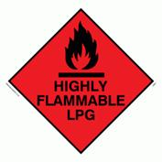](http://www.google.co.uk/url?sa=i&rct=j&q=&esrc=s&frm=1&source=images&cd=&cad=rja&uact=8&ved=0CAcQjRw&url=http://www.safetysignsupplies.co.uk/search/warning-signs/flammable-explosive/product/652/&ei=Juc4VYiSA4jhaP32gcAB&bvm=bv.91427555,d.d2s&psig=AFQjCNF5XCiiYvgSMo4LyXskFDlU9PcT8Q&ust=1429878903517244)

USEFUL CONTACT DETAILS

**KIRKLEES COUNCIL**

BUSINESS INITIATIVES UNIT: <http://kirklees.gov.uk/business/fundingDevelopment/index.aspx>

FOOD SAFETY / HEALTHY CHOICE / FINE 01484 221000

HEALTH & SAFETY 01484 221000

LICENSING 01484 221000

PLANNING 01484 221000

Email: [planning.contact.centre@kirklees.gov.uk](mailto:planning.contact.centre@kirklees.gov.uk)

REFUSE & WASTE 01484 221000

WEST YORKSHIRE TRADING STANDARDS: 08454 040506

WEST YORKSHIRE FIRE SAFETY 01274 385450

Email: [bradford.district@westyorksfire.gov.uk](mailto:bradford.district@westyorksfire.gov.uk)

<http://www.westyorksfire.gov.uk/>

**Business start up advice & support:**

* <https://www.gov.uk/>
* <http://business.leedscityregion.gov.uk/support/>
* HMRC - For information on starting a new business visit <http://www.hmrc.gov.uk/startingup/>

or call 0845 915 4515. To book on a free HMRC workshop call 0845 603 2691

**Business information:**

HSE Event management guide pages - <http://www.hse.gov.uk/event-safety/running.htm>